5TH Grade
https://www.khanacademy.org/math/cc-fifth-grade-math

BEFOR YOU START
Coach planning: Talk to your partner coach and make a plan on who will do what. Talk about the math topics and make sure you have a clear understanding of what you will be doing with the students.

Review: Before going over this material ask the student to find a math problem from their class work that week. Ask the students to write the problem in the chat. Then practice the student problems as a group.

Note: If the students seem confident in the work and they are doing well with the practice problem you can progress to the next level of that topic. An example would be if the students are doing fine with addition with decimals in the 10s place move to the 100s place.

What if only one student is struggling with the work? A great way to approach this is to use a student that can do the problems. Ask the student who does understand the math to explain to you, step by step how to solve the equation. Example ‘Jane can you tell me how to solve 2(3+5)=? What should I do first?’ this gives Jane a chance to show her skills but also does not draw attention to the fact that John is having a hard time.

Unit: Decimal Place Value
https://youtu.be/wtrrr15mbvQ
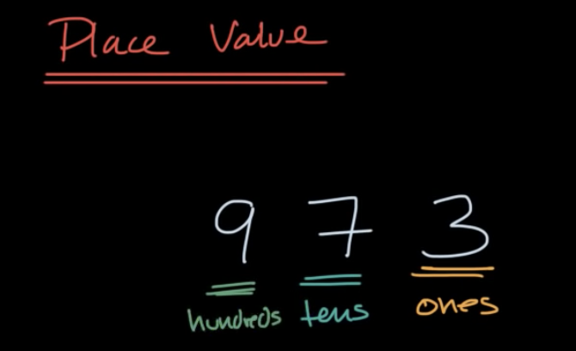

The 9 doesn’t just represent 9 but 9 hundreds or 900. Every time you go over a decimal place, you device by 10.
Ex: 900/10= 90
90/10=9
9/10=0.9
0.9/10=0.09
0.09/10=0.009
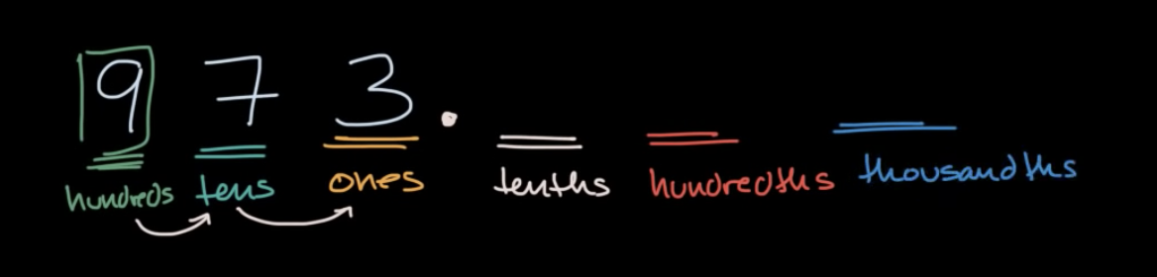

Exercise:
What is the place value of 5 in 59.085?
a. Hundreds
b. Thousands
c. Hundredths
d. thousandths

The answer is d. Thousandths.

Common fractions and decimals
https://youtu.be/lh2mp0aqSh8

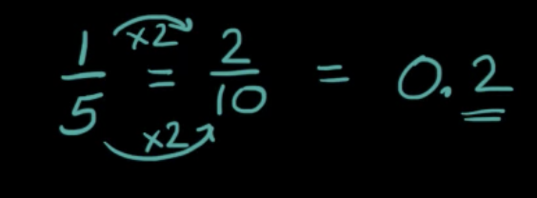
Remember whenever you device something by 10 you move the decimal place over? 2/10 would be 0.2.

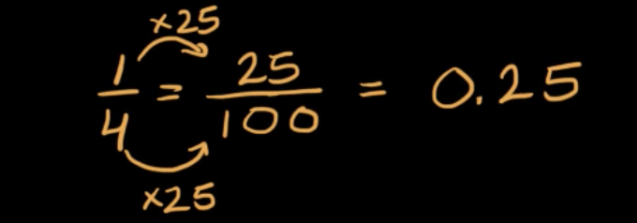
Because 4 is not a multiple of 10, then you would need to divide it by 100 instead of 10. So how many times does 4 go into 100? The answer is 25. So what you do to the bottom you must also do to the top. SO is you multiple 25 on the bottom you need to multiply 25 to the top.
25/100 as a decimal would be 0.25 because you would need to move the decimal over 2 places since its 100.

